Section 1 CANDIDATE DETAILS
Surname |  | First name | Middle or other name(s)
Title | Gender | Date of birth | Email address
Section 2 PARENT/GUARDIAN DETAILS (If under 18)
Surname |  | First name | Email address
Section 3 ACCESS ARRANGEMENTS
Specify which access arrangements are required.
- Supervised rest breaks
- 25% extra time
- 26% to 50% extra time
- Extra time over 50%
- Computer reader/reader
- Scribe/speech recognition technology/word processor with spellcheck, grammar and/or predictive text switched on
- Access to a mobile phone for medical purposes
- Listening to music/white noise due to a substantial impairment
SUPERVISED REST BREAKS AND/OR COMPUTER READER/READER
What is the nature of the candidate’s impairment?
Confirm the candidate’s normal way of working within their current learning environment.
25% EXTRA TIME AND/OR A SCRIBE
Detail the candidate’s current difficulties to show how they impact on teaching and learning and performance in examinations. Summarise evidence of feedback from teachers and/or support staff.
Confirm that 25% extra time and/or a scribe is the candidate’s normal way of working.
26% to 50% EXTRA TIME, OR EXTRA TIME OVER 50%
Confirm that the candidate has very persistent and significant difficulties when accessing and processing information and is disabled within the meaning of the Equality Act 2010.
Detail the candidate’s current difficulties to show how they impact on teaching and learning and performance in examinations. Summarise evidence of feedback from teachers and/or support staff.
Indicate whether the candidate will be working independently with:
- A braille paper
- A modified enlarged paper
Indicate whether the candidate will be using:
- A computer reader/reader
- A scribe
- A word processor
Confirm that extra time of up to 50% or over 50% is the candidate’s normal way of working.
ACCESS TO A MOBILE PHONE FOR MEDICAL PURPOSES
What is the candidate’s medical condition?
Confirm that the need to access the mobile phone during an examination is the candidate’s normal way of working.
LISTENING TO MUSIC/WHITE NOISE DUE TO A SUBSTANTIAL IMPAIRMENT
What is the nature of the candidate’s disability?
Confirm the need for the candidate to listen to music/white noise.
SPECIALIST EVIDENCE
NOTE: This is not required for supervised rest breaks or a computer reader.
Provide the centre a letter of report from:
- CAMHS
- A HCPC registered psychologist
- A registered specialist medical consultant
- A psychiatrist
- A speech and language therapist
- The Local Authority Specialist Service (e.g. Sensory Impairment Service or Occupational Health)
- A current EHCP, Statement of Special Educational Needs or Individual Development Plan
- Other appropriate medical evidence

ACCESS ARRANGEMENTS: SAMPLE OF EVIDENCE

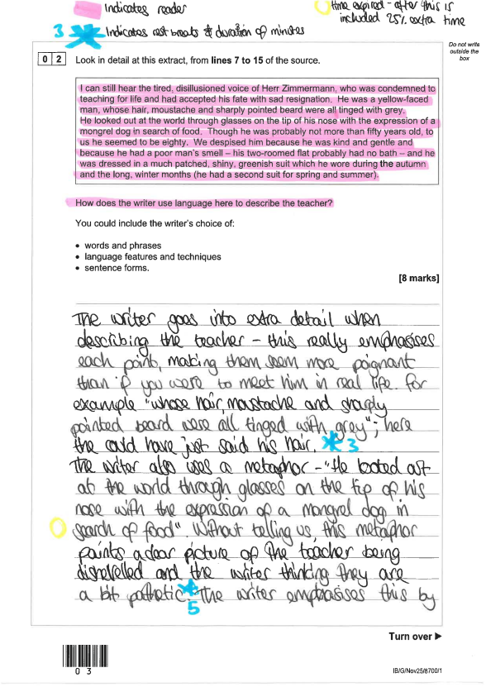

PRIVATE CANDIDATE: ACCESS ARRANGEMENTS EVIDENCE
25% Extra Time, Physical Disability | Evidence of persistent and significant difficulties which impact on teaching and learning, this must be confirmed by a formal diagnosis from a registered specialist, such as a clinical paediatrician or hospital consultant (not a GP).  To evidence the normal way of working, timed pieces of work recorded when normal time is used, for example “1hr taken” note in the margin, with an additional 15mins given to the completed piece.  Minimum of 5 pieces of work demonstrating this.
25% Extra Time, Medical Condition (ADHD, ASD, mental health conditions) | Evidence of persistent and significant difficulties which impact on teaching and learning, this must be confirmed by a formal diagnosis from a registered specialist, such as a clinical paediatrician or hospital consultant (not a GP).  To evidence the normal way of working, timed pieces of work recorded when normal time is used, for example “1hr taken” note in the margin, with an additional 15mins given to the completed piece.  Minimum of 5 pieces of work demonstrating this.
Computer Reader / Reader | To evidence need and the candidates’ normal way of working, a minimum of 5 pieces of work, with the part’s read to them being highlighted or underlined. If read more than once, a record of this to be made.
Rest Breaks | To evidence need and the candidates’ normal way of working, a minimum of 5 pieces of work, with notes in the margins where short breaks have been taken, including a log of the duration of each break. Evidence of need in any of the 4 areas (Cognition & Learning, Communication & Interaction, Social Emotional & Mental Health, Physical & Sensory) will be taken into consideration.
Prompt | A written statement from the candidates’ SENCO/teacher/tutor explaining the need for the prompt and outlining their normal way of working.
Word Processor | A written statement from the candidates’ SENCO/teacher/tutor explaining the need for the word processor and outlining their normal way of working in conjunction with the need they present with.  If the need for a word processor is a temporary difficulty, such as an injury, evidence of this will need to be presented for the exam.
Small/separate environment | A written statement from the candidates’ tutor / candidate / parent/carer (where appropriate) to support the need for a separate environment; this may be due to high levels of social anxiety, for example.

This list is not extensive; however, these are the most common access arrangements requested. If there are any different access arrangements requested, our SENCO will be in contact to discuss further.

